Definition of SOS (5.1.3 The timing of the start of the growth phase)

The growth phase is deemed to start whenever the value of the modelled time series exceeds a threshold defined as the initial base value *a0* (asymptotic model value well before the start of the growth phase) plus 5% of the amplitude *a1*.

Actually in the original code the SOS was defined using the fitted amplitude from inistart (and not a1):

fitmax = **MAX**(fitted [inistart:iniend], idx)

fitmax_idx = inistart + idx

fitmin1 = fitted [inistart]

fitmin2 = fitted [iniend]

relstart = **WHERE**(fitted [inistart:fitmax_idx] **GE** $

fitmin1 + (fitmax - fitmin1) * **0.05**, cnt)

startgs = inistart + relstart [**0**]

This may indeed be different from a0+5/100*a1.

However, my doubt is the following:

SOS depends on the amplitude of the curve (even if SOS does not change for linear transformation of the curve) meaning that two curves having the same rate of change in the initial growing phase can have a different SOS. For example, the following graphic show a curve taken from Tunisa.

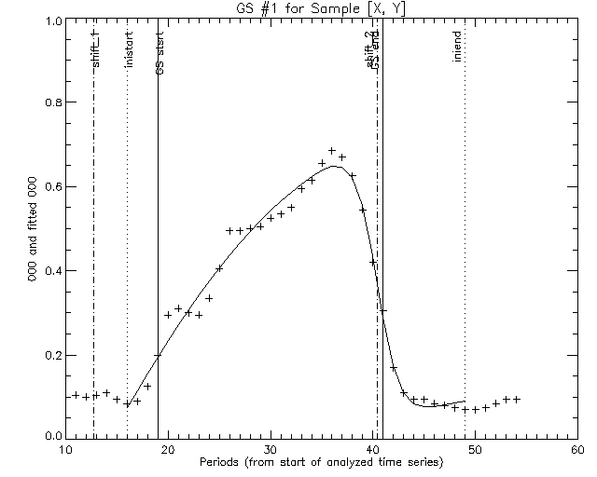

In the following I’ve just replaced any value > 0.35 to 0.35 fAPAR.

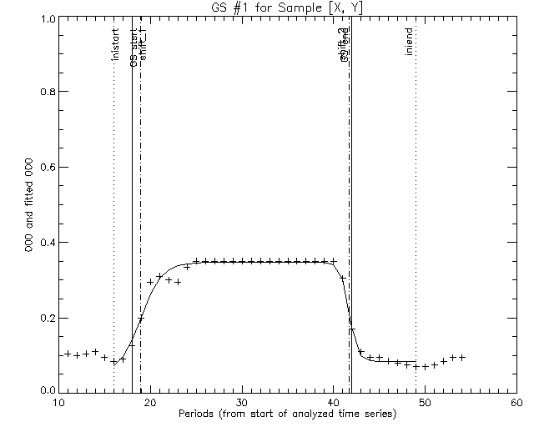

The initial growing phase is the same but the retrieved SOS is different. I have the doubt that this behaviour is not consistent. The SOS should be in principle unrelated to what happen later in the season.

It may be of particular concern when we compute the fAPAR integral between SOS and EOS if, as it seems to me, our procedure has the effect of broadening the length of the season when the amplitude is reduced. In that case we would reduce the difference in the integrals of two seasons having similar start and end, but reaching different amplitude.

What is your opinion?

I was thinking to use, instead of a % of the amplitude, some local metric specific to the initial and ending phases. Something like the maximum rate of change (max of second derivative of the fitted curve) as I did before when using a double logistic curve. Do you think it make sense? By the way, I tried a little bit but I got stuck in deriving and solving the double hyperbolic tangent model .. But I guess this issue is somehow solvable..